Rev Paul Henry Ellenberger (1868-?)
Childhood and early adulthood
Paul was born on 25 August 1868 in Clerkenwell, north London. The 1871 Census shows him, aged two, living at 32 Devonshire Street, Islington, with:
- his father Henry aged 40, born in Switzerland, type founder’s clerk
- his mother Celina aged 43, born in France, and
- his sister Lydia May aged 3, born in Clerkenwell.
He was still at this address by the time of the 1891 Census, living with his mother (now widowed), his sister Lydia (a private governess), his brother John aged 19 (a stockbroker’s clerk) and two other households. His employment is given as Assistant Teacher, Board School.
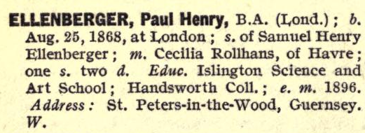
Marriage, Family and Ministry
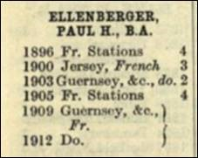
He trained for the ministry at Handsworth College, Birmingham and was awarded a B.A. (London). He entered the ministry in 1896 and started four years in ‘French Stations’ as a Wesleyan minister (see information from the 1912 edition of Alphabetical Arrangement of All the Wesleyan Methodist Ministers… commonly referred as ‘Hill’s Arrangement’).
Extract from ‘Hill’s Arrangement’ 1912
Extract from Methodist Who’s Who 1912
In the first quarter of 1896, he married Cécile Rollhaus in Fulham, London (from other later sources we find that she was born in le Havre in about 1864). His first daughter Lillian E was born in 1899, his second, Ruth Mabel, in about July 1900, and his son Samuel in about 1908, all three born in le Havre.
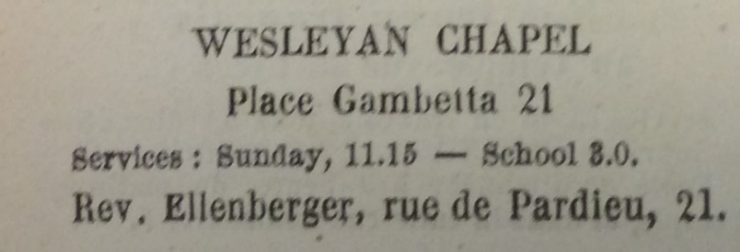
His next station was in Jersey from 1900 to 1903, followed by Guernsey from 1903 to 1905, and then back in ‘French Stations’ from 1905 to 1909. The Annuaire du Havre for 1908 shows that he was then living in le Havre and was minister at the Wesleyan chapel there (link), at no. 21, Place Gambetta.
From the 1908 Annuaire du Havre

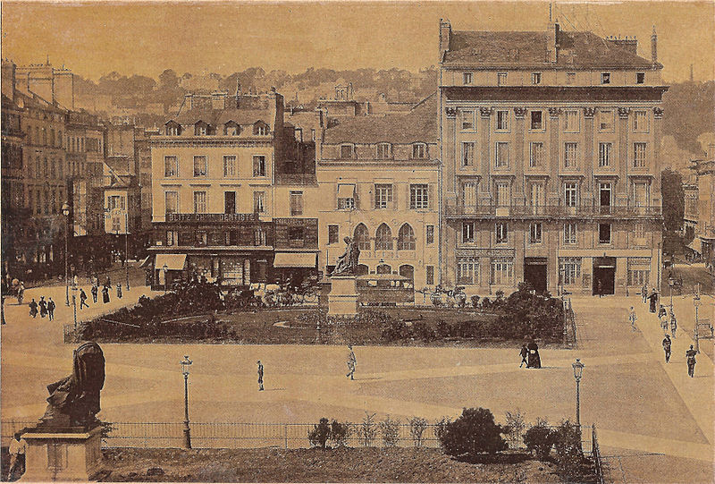
Place Gambetta (previously Place Louis XVI) looking north (late 1800s)
(the chapel building is marked with an arrow)

My family connection with Rev Ellenberger
For many years I have been researching the fascinating story of my great grandfather’s step-sister Hannah Vimont, née Wells. She was born in Stepney in the London Docklands in 1823. In about 1848, then aged about 25, she left home and travelled to le Havre. She styled herself as a primary teacher and worked for a widowed lawyer, M. Emile Vimont, presumably to help bring up his son (born 1844). She lived with the father and son, later being variously described in the censuses as a servant or a housekeeper. After thirty years living in the Vimont household, she married M. Vimont in 1878; sadly he died only six months later. She remained in the apartment for another thirty years until she died in January 1908. Her death certificate names two witnesses: my grand-father Richard James Wells and Paul Ellenberger, ‘pasteur and friend of the deceased’. We do not know whether Paul was with her because she had been a member of the Wesleyan chapel (which opened in 1850) for some or all of the sixty years she spent in le Havre or whether she had just known Rev Ellenberger socially in recent years.
Rev Ellenberger after 1908
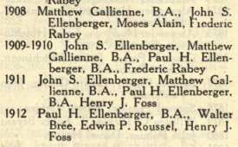
Hall’s Circuits and Ministers for 1912 and again for 1913-23 shows that Rev Paul Ellenberger was stationed in Guernsey from 1909 until 1914. Interestingly, a John S. Ellenberger also appears as a minister (no degree qualification given) in the Guernsey circuit from 1908 – 1912; this must be Paul’s younger brother John Samuel who was born in Islington in about August 1971. Strangely, Paul appears in Kelly’s Directory for 1913 where he is listed as a Wesleyan minister living in Broadstairs, Kent. No further record has been found of him or of his brother John:
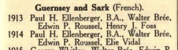
- he is not mentioned in the 1920 or later editions of Hill’s Arrangement either as a working Minister or among those who have ‘died in the work’
Extract from ‘Hall’s Circuits and Ministers 1912
- he does not appear in the WW1 British servicemen records, though he could have served in the French military
- he does not appear in the British death records, though he could have died in France.
Extract from ‘Hall’s Circuits and Ministers 1913-23

