The Old Chapel, Albert Road, Widnes

When I was a small boy, living in Halton View, and attending Wesley Sunday School (a site now occupied by Trinity Methodist Church) I used to pass a plot of waste land opposite the Albert Hotel at the S bend at the bottom of the Halton View bridge – the junction of Albert Road and Halton View Road. Although waste ground, it had the remnants of a boundary wall in exactly the same style as the boundary wall of Wesley Chapel. I was told that it was the site of the original Wesley Church which burned down around the turn of the century, circa 1900. The site is now occupied by a car sales business.

Imagine my surprise, therefore, when our new minister, Jenny, was checking the contents of the manse filing cabinets, and she unearthed a small box in which there were four glass photographic slides. The box was labelled “Albert Road Wesleyan Chapel – burned down”. One slide shows the interior (obviously before the fire) and two others show the internal damage with a dark interior against the brightness of the sky through the exposed and open roof, a light contrast that would challenge even the most modern photographer. There is one decent slide with a corner broken away, depicting the external view of the damaged chapel.

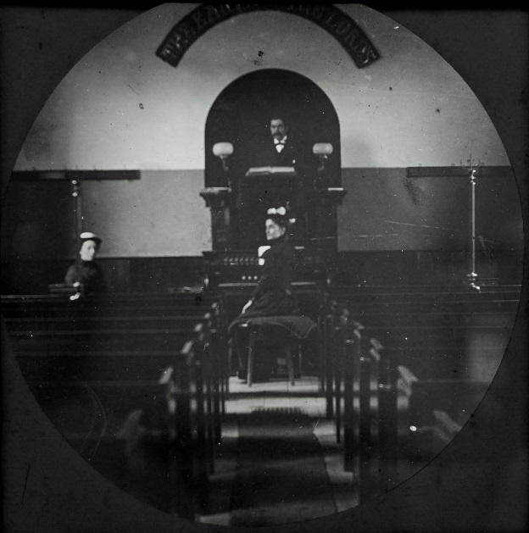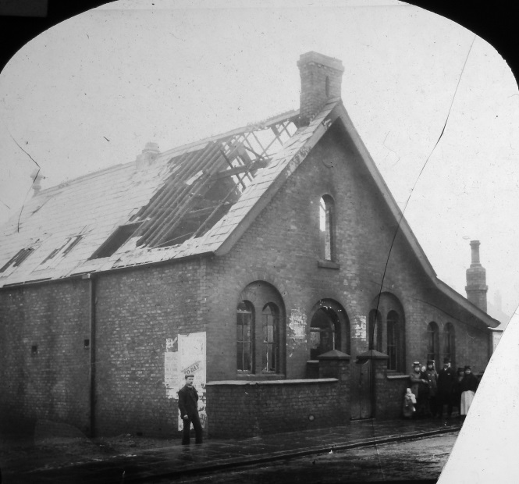

Inside Albert Road Chapel Albert Road Chapel after the fire

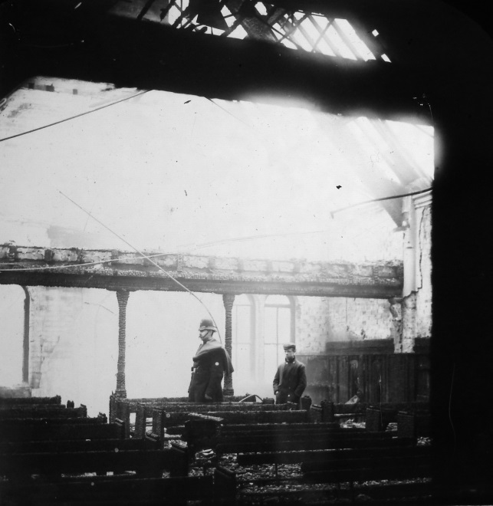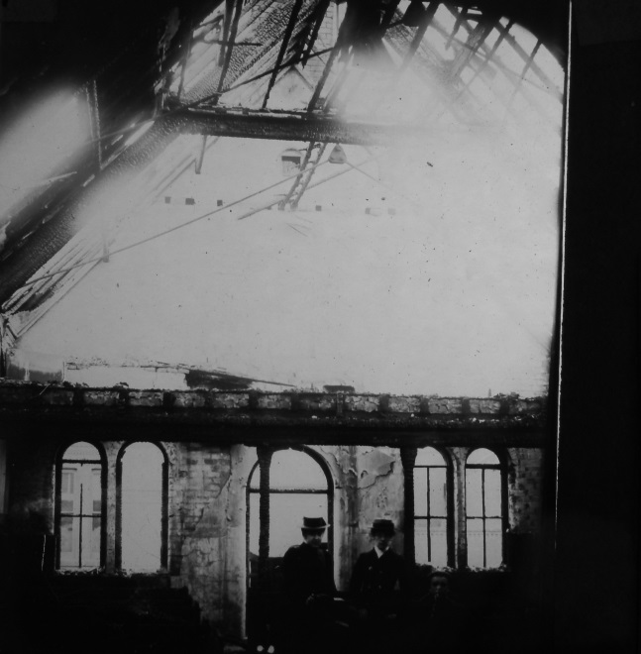

Albert Road Chapel Fire Damage Albert Road Chapel Fire Damage

I understand that Wesley Chapel was opened in February 1905, so it does seem possible that the Albert Road Chapel was the forerunner of Wesley.

Brian Fisher.

Following the preparation of the original article, the following reference was found
http://cheshiredirectories.manuscripteye.com/pdf/1895/04/section.pdf.
It appears to be a census report identifying the streets and premises of Widnes in 1895. Churches are listed, and each street is detailed by address and householder. The Albert Road Chapel is clearly listed both amongst the churches and its location in Albert Road. The following are extracts from this source.
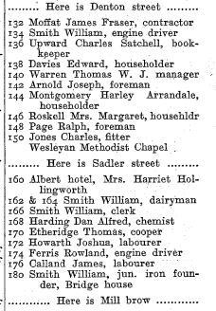
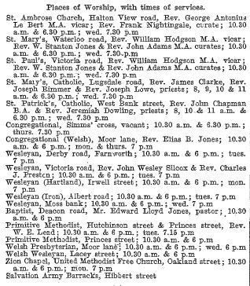

Places of Worship, Widnes, 1895 Albert Road Properties, Denton St to Mill Brow 1895

The following illustrations identify the location of the old Albert Road Wesleyan Chapel.

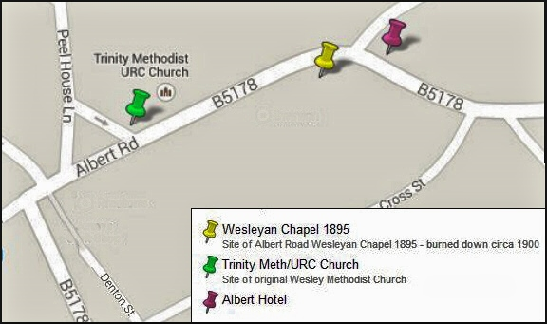

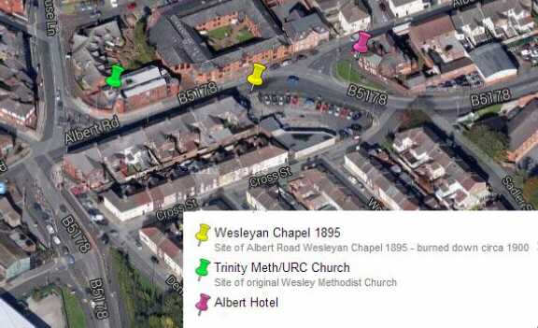

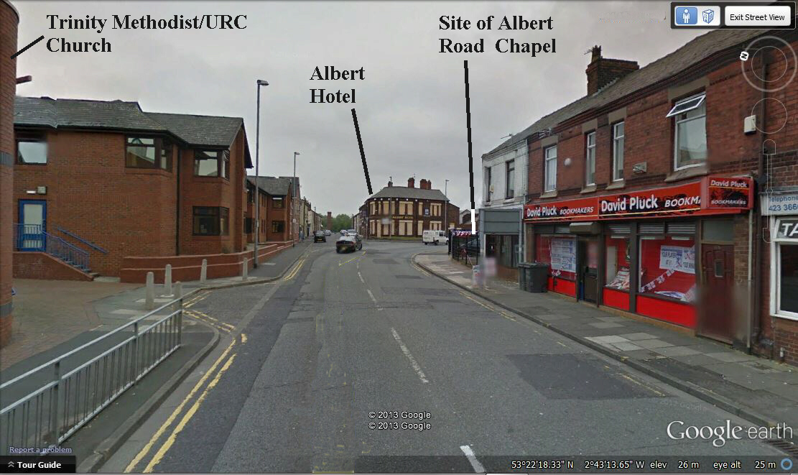

A local publication “Forward in Faith” (Trinity Church Souvenir Booklet) issued at the opening of Trinity dates the fire to 1901. It states that the Albert Road Chapel was built in 1874 and an extension added in 1889. The extension survived the fire and permitted activities to continue. A new Wesleyan Chapel in Peel House Lane, called Wesley Church, was opened on February 14th 1905.

After the First World War, a Memorial Hall was added to Wesley Church (to the left on the following photograph). In 1983, because of the high cost of necessary repairs and renovation, it was decided that the building had to be demolished. Once again, the Memorial Hall extension was put to use as temporary accommodation, and shortly after the decision to demolish, fire destroyed the main building.

The following is a reproduction of a postcard from the 1905 era, before the addition of the Memorial Hall.

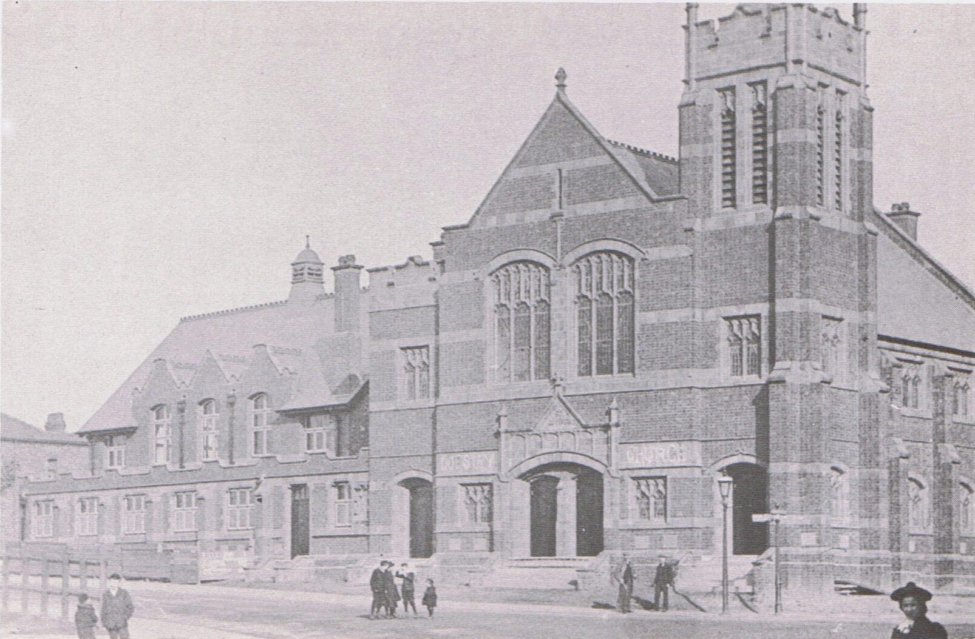

Wesley Chapel circa1905

In 1984 three churches combined to form Trinity Methodist/URC Church and activities continued in the residue of their various buildings. The premises at Trinity were built on the Wesley site to house the joint congregations of the three churches, Wesley Methodist, Frederick Street Methodist (Frederick Street Widnes) and Milton United Reformed (formerly Congregational) Church (Milton Road/Widnes Road Widnes). Trinity Methodist/URC Church was opened on 18th April 1992.
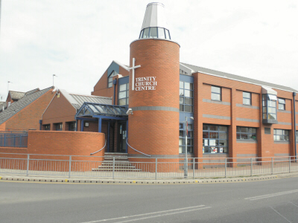

Trinity Methodist/URC Church 2011

